Bhagavad Gita Chatbot Assignment

The goal here is to build a chatbot that doesn't try to know everything, but knows one thing really well. For this assignment, I chose the Bhagavad Gita as the domain - a 700-verse scripture that's part of the Mahabharata and contains some of the most influential philosophical teachings in human history.
For this assignment, I went with a retrieval-based approach using TF-IDF and cosine similarity. It runs entirely offline, doesn't need any paid services, and works really well for a focused domain like the Gita where the questions tend to be predictable.
Streamlit build a working web app in pure Python. No HTML, no JavaScript — just write Python code and Streamlit handles the UI. A few lines of code give you input boxes, chat bubbles, sidebars, and more.

Setup-
Install the libraries needed for the project:
pip install streamlit scikit-learn
Project structure
three files in one folder:
gita_chatbot/
├── app.py # Streamlit UI
├── knowledge_base.py # Gita Q&A data
└── chatbot.py # The matching logic
Keeping things in separate files makes the code cleaner. we can add more Q&A later.
Step 2: Building the Knowledge Base
The knowledge base is a list of question-answer pairs covering the main topics of the Gita. I grouped them into categories: basic introduction, main characters, key concepts (karma yoga, bhakti yoga, dharma, moksha), famous teachings, chapter summaries, practical life applications, and conversational responses like greetings.
some questions answers from knowledge_base.py:
knowledge_base = [
{
"question": "What is the Bhagavad Gita?",
"answer": "The Bhagavad Gita is a 700-verse Hindu scripture..."
},
{
"question": "Who is Krishna?",
"answer": "Krishna is the central figure of the Bhagavad Gita..."
},
{
"question": "What is karma yoga?",
"answer": "Karma Yoga is the path of selfless action..."
},
{
"question": "What does Krishna say about death?",
"answer": "Krishna teaches that the soul is eternal and indestructible..."
},
{
"question": "Namaste",
"answer": "Namaste! I'm here to help you explore the wisdom of the Gita."
}
]

I added about 35 question-answer pairs covering:
- Introduction to the Gita and its origin
- Main characters — Krishna, Arjuna, Pandavas, Kauravas
- Key concepts — Karma Yoga, Bhakti Yoga, Jnana Yoga, dharma, moksha, atman, Brahman
- Famous teachings about death, duty, mind control, anger, fear
- Chapter summaries (especially Chapter 2 and Chapter 11)
- Practical life applications — meditation, food, emotions
- Conversational responses — greetings, thanks, goodbye

Step 3: Building the Matching Logic
The bot needs to figure out which question in the knowledge base most closely matches what the user typed. I used TF-IDF to turn text into numbers and cosine similarity to find the closest match.
Here's the core of chatbot.py:

import re
from sklearn.feature_extraction.text import TfidfVectorizer
from sklearn.metrics.pairwise import cosine_similarity
class Chatbot:
def __init__(self, knowledge_base):
self.kb = knowledge_base
self.questions = [item["question"] for item in knowledge_base]
self.answers = [item["answer"] for item in knowledge_base]
self.vectorizer = TfidfVectorizer(
stop_words='english',
lowercase=True,
ngram_range=(1, 2)
)
self.question_vectors = self.vectorizer.fit_transform(self.questions)

def clean_input(self, text):
text = text.lower()
text = re.sub(r'[^a-z0-9\s]', '', text)
text = re.sub(r'\s+', ' ', text).strip()
return text

def get_response(self, user_input, threshold=0.2):
cleaned = self.clean_input(user_input)
if not cleaned:
return "Could you please type your question again?"

user_vector = self.vectorizer.transform([cleaned])
similarities = cosine_similarity(user_vector, self.question_vectors).flatten()
best_idx = similarities.argmax()
best_score = similarities[best_idx]

if best_score < threshold:
return ("I'm not sure I understood that. I can help with topics from the "
"Bhagavad Gita — its teachings, characters, chapters, and how its "
"wisdom applies to daily life. Could you rephrase your question?")
return self.answers[best_idx]
• TF-IDF Vectorizer turns each question into a numerical vector. The ngram_range=(1, 2) setting lets it consider both single words and word pairs, which helps with phrases like "karma yoga" or "chapter 11".
• cosine_similarity measures how close the user's question is to each known question. The closest match wins.
• Threshold is the safety net. If no question scores above 0.2, the bot admits it doesn't know rather than guessing — important for a spiritual topic where wrong information could mislead someone.

Step 4: Building the Streamlit UI
This is where the chatbot becomes a real interactive app. Streamlit's chat components handle all the visual styling automatically ------- no CSS or HTML needed.
import streamlit as st
from chatbot import Chatbot
from knowledge_base import knowledge_base

st.set_page_config(
page_title="Bhagavad Gita Guide",
page_icon="🕉️",
layout="centered"
)

st.title("🕉️ Bhagavad Gita Guide")
st.markdown(
"Ask me about the teachings, characters, chapters, "
"and timeless wisdom of the Bhagavad Gita."
)

with st.sidebar:
st.header("About")
st.write("A conversational guide to the wisdom of the Bhagavad Gita.")

st.subheader("Try asking:")
sample_questions = [
"What is the Bhagavad Gita?",
"Who is Krishna?",
"What is karma yoga?",
"What does Krishna say about death?",
"What is dharma?",
"How can the Gita help in daily life?",
]
for q in sample_questions:
st.markdown(f"- {q}")

if st.button("🗑️ Clear chat"):
st.session_state.messages = []
st.rerun()

@st.cache_resource
def load_chatbot():
return Chatbot(knowledge_base)

bot = load_chatbot()

if "messages" not in st.session_state:
st.session_state.messages = [
{"role": "assistant",
"content": "Namaste! I'm here to help you explore the wisdom of the Bhagavad Gita."}
]

for msg in st.session_state.messages:
with st.chat_message(msg["role"]):
st.markdown(msg["content"])

if user_input := st.chat_input("Ask about the Bhagavad Gita..."):
st.session_state.messages.append({"role": "user", "content": user_input})
with st.chat_message("user"):
st.markdown(user_input)

response = bot.get_response(user_input)
st.session_state.messages.append({"role": "assistant", "content": response})
with st.chat_message("assistant"):
st.markdown(response)
--------------------------------------------------------------------------------------------------------------------------------------
In each section:
• st.set_page_config sets up the browser tab title and the page icon (🕉️ here).
• Sidebar shows sample questions to help users get started — really useful for a new chatbot.
• @st.cache_resource ensures the chatbot is built only once, not every time the user types something.
• st.session_state.messages stores the chat history so messages stay visible as the conversation grows.
• st.chat_message and st.chat_input are Streamlit's built-in chat widgets that give the polished look automatically.

Step 5: Running the App
From the project folder in Command Prompt or terminal:
python -m streamlit run app.py
Streamlit opens the app in your browser at http://localhost:8501. The chatbot is now ready to use.
I have added some screen shot below
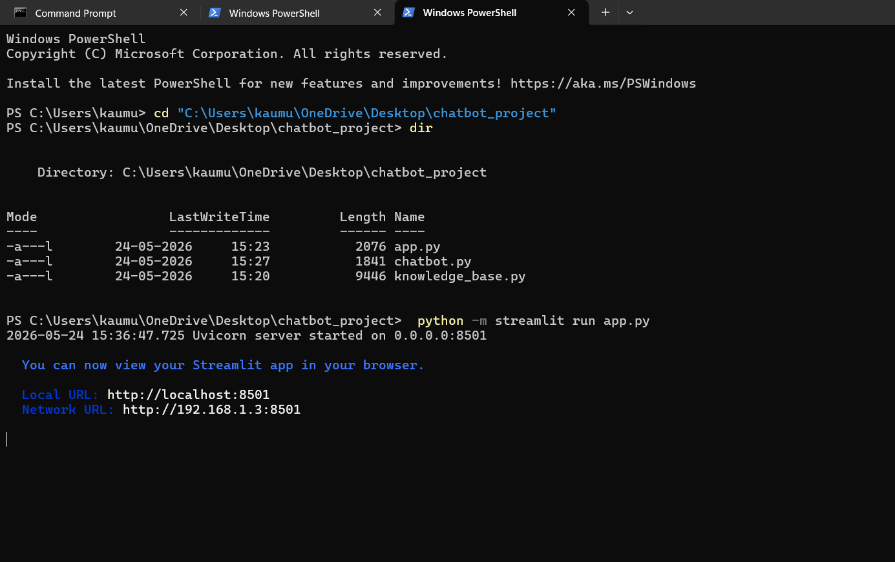

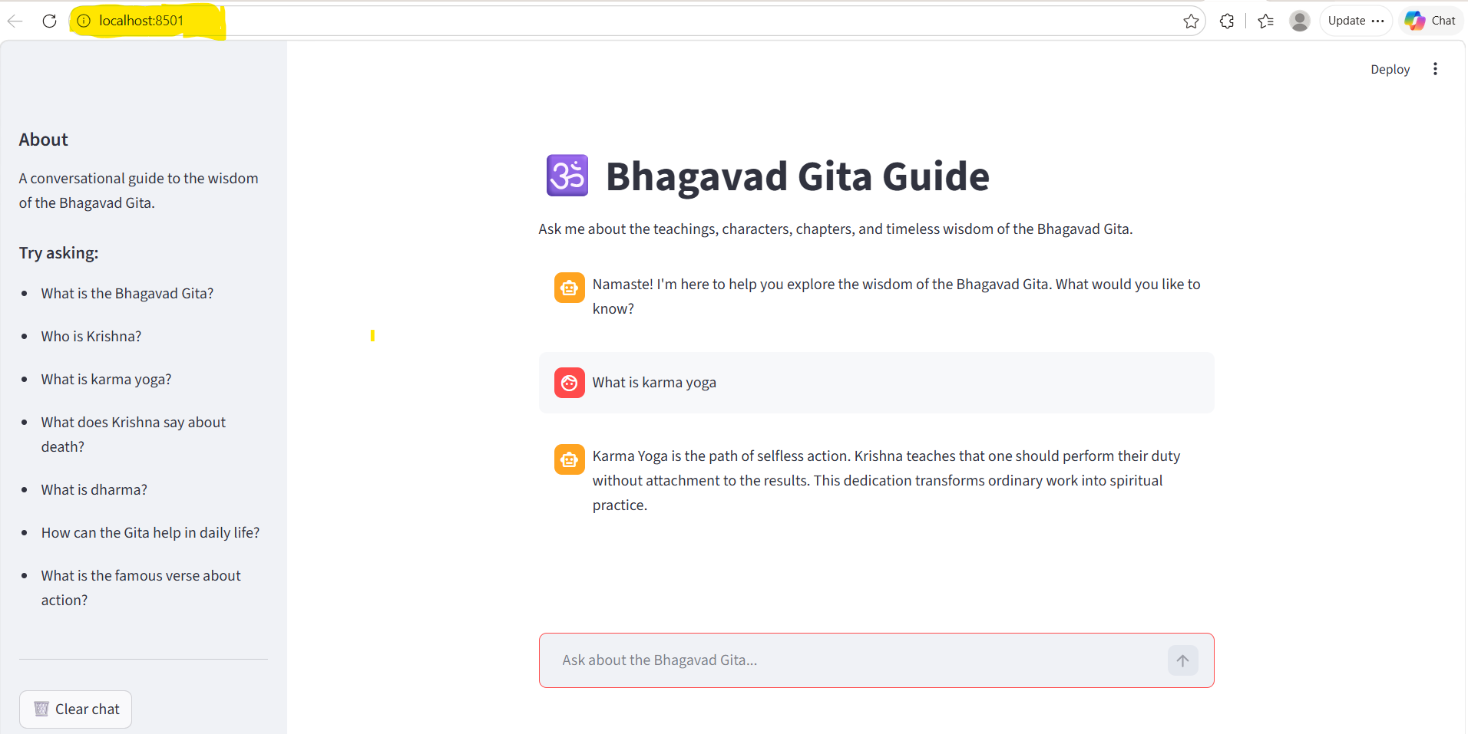

END
Assignment done by – Kaumudi Rajesh kumbhar

